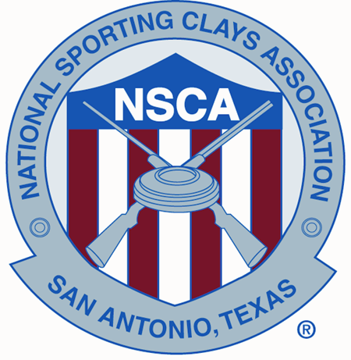

September 26, 2016

Name
Address
City, State Zip code
Country

Dear Name;

I would like to personally extend an invitation to you to attend the following shoots held at the National Shooting Complex in San Antonio, TX, as well as any other NSCA registered tournaments to be held in the United States during 2017. For events at the National Shooting Complex, forms for Pre-Registration, Advance Entry, Clays Cars, Gun Permits etc. are available at www.mynsca.com . Please visit the club websites for information on the other events.

West Regional – Coyote Springs – Tucson, AZ – March 23-26, 2017

World English Sporting Clays Championship – National Shooting Complex - San Antonio, TX – April 27-30, 2017

Northeast Regional – M & M Sporting Clays – Pennsville, NJ – May 16-21, 2017

U.S. Open – Big Red Oak Plantation – Gay, GA – June 5-11, 2017

North Central Regional – Caribou Gun Club – Le Sueur, MN – August 3-6, 2017

South Central Regional – Providence Hill Farm Sporting Club - Flora, MS – September 6-10, 2017

Southeast Regional – The Fork – Norwood, NC – September 27- October 1, 2017

NSCA National Championship – National Shooting Complex – San Antonio, TX - October 21-29, 2017

Sincerely,

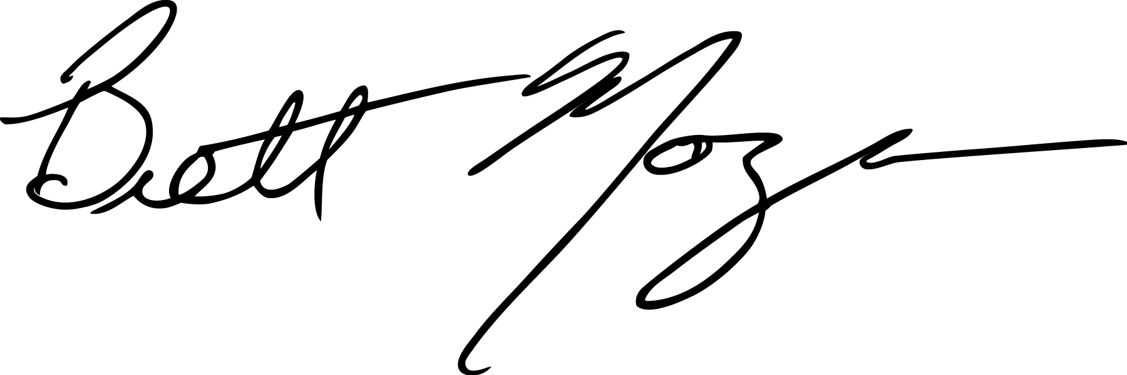
Brett Moyes
NSCA Director

