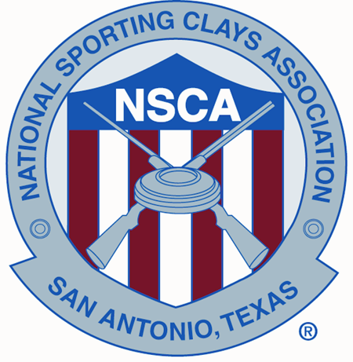

January 21, 2019

Name
Address
City, State Zip

Dear First Name;

I would like to personally extend an invitation to you to attend the following shoots held at the National Shooting Complex in San Antonio, TX, as well as any other NSCA registered tournaments, practice or instruction taken at any NSCA member clubs to be held in the United States during 2019. For events at the National Shooting Complex, forms for Pre-Registration, Advance Entry, Clays Cars, Gun Permits etc. are available at www.mynsca.com . Please visit the club websites for information on the other events.

Western Regional – Coyote Springs Sporting Clays – Tucson, AZ – April 8-14, 2019

US Open Sporting Clays – M & M Sporting Clays – Pennsville, NJ – May 12-16, 2019

North Central Regional – Claythorne Lodge – Hallowell, KS – June 12-16, 2019

South Central Regional – Providence Hill Plantation – Flora, MS – July 17-21, 2019

World English Sporting Clays Championship – Northbrook Sports Club – Hainesville, IL – August 5-11, 2019

Northeast Regional – Cardinal Shooting Center – Marengo, OH – September 4-8, 2019

Southeast Regional – Backwoods Quail Club – Georgetown, SC – October 2-6, 2019

NSCA Nationals – National Shooting Complex – San Antonio, TX – October 19-27, 2019

Sincerely,

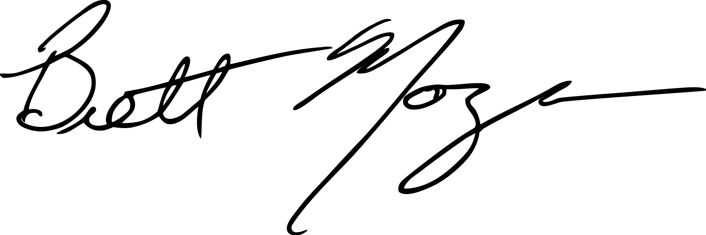
Brett Moyes
NSCA Director
5931 Roft Road
San Antonio, TX 78253
Phone – 210-688-3371 ext. 124
Email bmoyes@nssa-nsca.com

