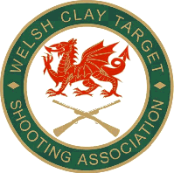
WELSH CLAY TARGET SHOOTING ASSOCIATION LTD
Cymdeithas Saethu Targedau Clai Cymru Cyf
Valmai Matulla, General Secretary WCTSA Ltd, 1 Glanrafon, Trefor, Caernarfon, Gwynedd, LL54 5HP
Tele: 01286 660049/07766767205 email; wctsa@hotmail.co.uk www.wcsta.co.uk
18/05/2018
Dear All

Due to unforeseen circumstances, the 2018 English Sporting Home Countries International Tournament has been moved to:-

Mid Wales Shooting Centre
Ffinnant
Trefeglwys
Caersws
Powys
SY17 5QY
01686 430654
www.midwalesshootingcentre.com

Owing to the venue change, unfortunately the open competition scheduled to be held on Sunday 9th September will not take place. We will however forward you details of alternative shoots that are available at other grounds in due course.

The practice and squad selection will still be held on Friday 7th September at Mid Wales Shooting Centre.
The banquet hotel and all other details for the event remain unchanged.

We apologise for any inconvenience this may have caused and look forward to seeing you on the 8th September.
If you have any queries, please don't hesitate to contact the event coordinators:-

Richard Hughes - 07779 026012 Nicola Walker - 07775 335763 nicola.walker28579@gmail.com

Yours sincerely
Valmai
Valmai Matulla
General Secretary – WCTSA Ltd

