The Clay Pigeon Shooting Association Ltd
Edmonton House, National Shooting Centre,
Brookwood, Woking,
Surrey, GU24 0NP
Telephone: +44 (0) 1483 485400 Fax: +44 (0) 1483 485410

12th November 2019

Dear Secretary,

The Clay Pigeon Shooting Association wishes to extend a very cordial invitation to your Association to participate officially in the forthcoming:

20th Fitasc Sporting Home Countries International Tournament

To be held at: Atkin, Grant & Lang Shooting Ground
Windmill Road
Markyate
St. Albans
Hertfordshire
AL3 8LP

Tel: 01582 849382
www.agl-uk.com

On: Saturday 28th September 2019

The Tournament will be held over one day of 100 targets and Teams will consist of the following:

Senior/Open: Teams of 9 shooters (6 scores to count)
Ladies: Teams of 2 shooters (2 scores to count)
Juniors: Teams of 2 shooters (2 scores to count) Under 21 on 01/01/2019
Veterans: Teams of 2 shooters (2 scores to count) 55 or over on 01/01/2019
Super Veterans: Teams of 2 shooters (2 scores to count) 65 or over on 01/01/2019

The entry fee is £62 per person for the HCIT competition.

Squad selection will take place at 3pm on Friday 27th September at Atkin, Grant & Land, with Team Managers requested to please be in attendance.

Sporting Practice will be available at the ground from Tuesday to Friday (9am-5pm), with an open 100 FSP Registered competition taking place on Sunday 29th September.

The post-Tournament banquet and Team photographs will take place at Holiday Inn, Luton South.
London Road,
Markyate,
Luton,
AL3 8HH

www.hilutonsouth.com
Tel: 0871 942 9281

The photographs’ will take place at 6.30pm, with the banquet commencing at 7pm. Banquet tickets will cost £42 per person, with final numbers attending, top table names, and any special dietary requirements, all required at least 2 weeks prior to the event.

Accommodation has been held at the Holiday Inn for Friday and Saturday evening at a cost of £75 per room per night, Bed and Breakfast. Single occupancy rate is £65.00 per room per night, Bed & Breakfast. Please quote code FSP2709 when booking to secure these rates. Alternative hotels in the area are:

Linton Hotel Luton – 01582 407644 – www.lintonhotelluton.co.uk
Holiday Inn Express Dunstable – 0871 9429038 – www.ihg.com
Thistle Express Luton – 01582 734199 – www.thehotelcollection.co.uk

Please ensure that all Trophies are returned to the ground by 3pm Friday 26th September.

For anyone requiring a Visitors shotgun permit, please note that the requirements for these have changed and therefore the application process may take longer. Please allow 60 days for the processing of VSP Applications. For further information, please refer to the following link. https://www.cpsa.co.uk/vsp

The CPSA looks forward to welcoming your teams to Atkin, Grant & Lang.

Yours Sincerely,

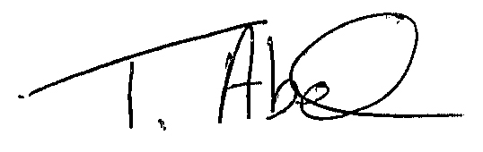
Trudy Abel
England Team Co-ordinator
trudy@cpsa.co.uk
01483 485401.

