England Team Manager’s Report
14th World DTL South Africa at Valley Target Clay Club 29/30/31 March 2023.

Preceding the DTL World Championships, the National South African Championships took place including the Mackintosh International Postal Championship for The Macintosh Trophy where all of the Home Countries, South Africa, New Zealand and Australia participated. Started in 1939 (introduced by Mr Donald Mackintosh a world renown shooter) it includes all the classes; the perpetual trophy is held in Australia and the event is administrated there too. In England we submit the scores from the Home Internationals. The disciplines included Handicap-by-Distance, Singles, Double Rise, and DTL gave the England shooters a good start.
Geoff Howlett won the 200 DTL event after a shoot off with the New Zealand Junior James Sullivan. It went one full round then half way through the next round James dropped a target.
Paul Chaplow shot a cracking 100 singles on the first day which gave him a podium finish along with 3 other medals including the ATA Trap overall High Gun (1687).
Other medals were won by Nigel Chapman (3 medal), David Amos, (3 medals) other podium finishes included New Cap Lorrie Greening, Matt Sheldrake, Emma Holden, Cliff Pain, Clive Weston and Ted Philipson (Universal Trap and Double Trap).

The DTL World Championship Opening Ceremony took place on the Tuesday 28 March 2023 which started with a walk pass with the National Anthems being played followed by drinks and some classy Canapes.
The start of the Worlds greeted the shooters with a real hard blowy day affecting the targets all over the place, although bright sunshine which gave good visibility but on many targets it was the luck of the draw.
Somebody always does well whatever the condition and it came from the Welsh Shooter Elis Jones on 100/297 who took high gun on the day followed by Aussie Ashley Hawker on 296 then England Captain Nigel Chapman on 100/295.
We had another one shooter in the nineties that of Geoff Howlett on 291.
We had another 6 shooters from England in the 280 plus (including the Junior Toby Hurstfield) and the rest just a little off the pace.
All the teams were determined to do well tomorrow and get a podium place (they better as I have the pennants here). The England individuals were also just a little off the pace. Tomorrow is another day as they say and we were expecting higher scores.

The next day the weather was just the same high winds and sunshine.
Elis Jones (Wales Senior) did one better shooting a lovely 100/298, Ashley Hawker (Australia Senior) posted a 100/297 and Mathew Stokes (Australia Senior) 100/298 kept the pressure on Elis, John Sleightholme 99/295 (Australia Vet) equalled Nigel Chapman’s score after 2 days for Veteran.
The main Ladies contention after the second day was Bella Woolcock (Australia) 575, Jessica Robb (Australia) 568 and England Emma Holden 561. On the super final day Emma posted a 50/148 which kept her in touch with the silver, Bella was way out in front and Jessica was hanging in. In the last 25 target the bronze and silver changed hands 3 times and up until the last target they were both equal and then Jessica missed her last target which gave Emma the Silver for the Worlds Ladies runner-up title.
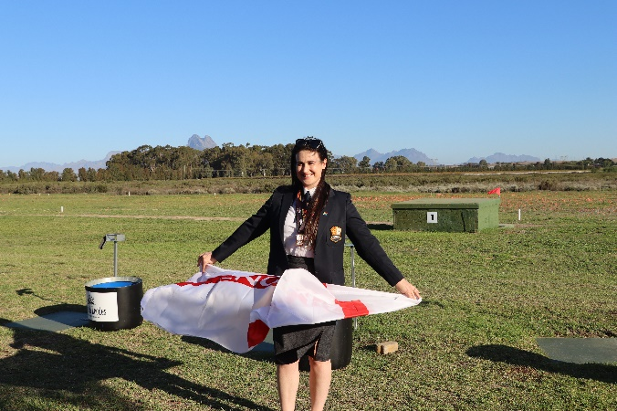
Emma Holden – Won Silver for the Worlds Ladies Runner-Up Title

In Nigel Chapman’s case on the Super Final day his rival, John Sleightholme and himself matched target to target until John dropped a half target which opened the door for Nigel in the last 25 target and that’s all it needed to clear up winning by a half the Worlds Veteran Title. On the day Nigel shot 100/299 and John 100/298. Both finals kept us sitting on the edge of our seats. Nigel also won silver in AA class.
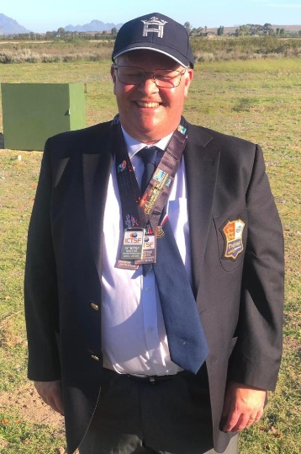
Nigel Chapman 2023 DTL World Veteran Champion

At the end of the second day the England Teams had done really well the Ladies won the Bronze missing out by 2 points to take silver which included 2 new caps in the team.
The Super Vets missed the Gold by 2 points to take silver and the Vets took bronze. The Senior team came 4th a few points away from the bronze. Best scores in the Seniors came from Geoff Howlett (569) and David Weston (866).
Welsh shooter Elis Jones carried on where he left off and shot a fabulous 100/300 to win the World Title on the last day, 8 points away from his closet rival.
David Baugh from Wales won the World Super Vets title to keep Elis company. I should also mention the World Junior was won by Cody Brady with a total 869 (plus Gold in the team event) from Northern Ireland and Roan Quinn (853) the Bronze for Ireland (plus silver in the Team event. The Seniors team runner up title was also won by Ireland.
I would like the shooters to give themselves a pat on the back for putting themselves in these nerve-racking experiences on the world stage in this prestigious event especially the new caps. Team events are very stressful, in the sense, if a target or point drops things start to play on your mind then it can go either way. All the team went the right way!
I would like to thank the England DTL Team and the dozen individuals who participated in the DTL Worlds, always very smartly turned out and who went about their business in a very professional way, accepting the targets as they were.
There was a real shortage of ammunition owing to the war in the Ukraine and transport costs to South Africa which led to the majority of shooters not shooting with their preferred shell. Despite the ammunition situation as well as a number of the England Team being ‘under the weather’ the Team performed really well (that old British bulldog approach)!
Lastly thank you to the Governing body CTSASA (Sarah Kalell) and the Valley Clay Target Club (Rob Henderson and Crew) for running a terrific shoot and the kindness they offered, nothing was too much trouble and when something did go wrong it was corrected immediately and thank you to Jenny in the office for not losings her rag as I pestered her constantly for printing, updates etc.
It’s a long way to go but the DTL Worlds are coming home next year (2024) to Bywell.

David Amos
DTL England Team Manager

DTL England Team Photographs – DTL World Championships 2023
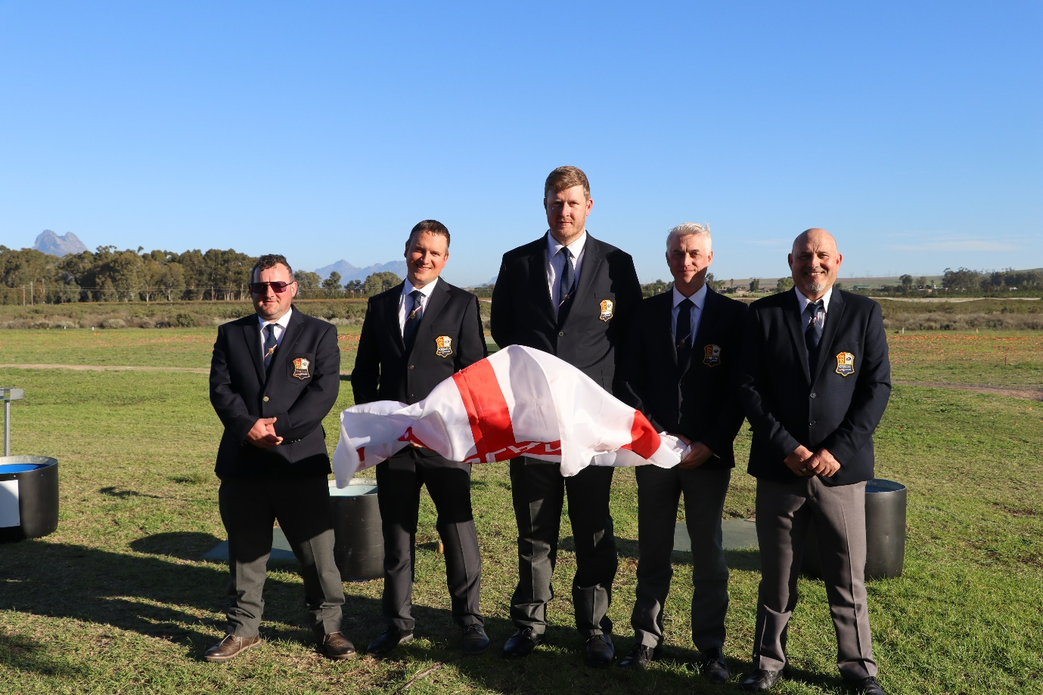
England DTL Senior Team – DTL World Championships 2023
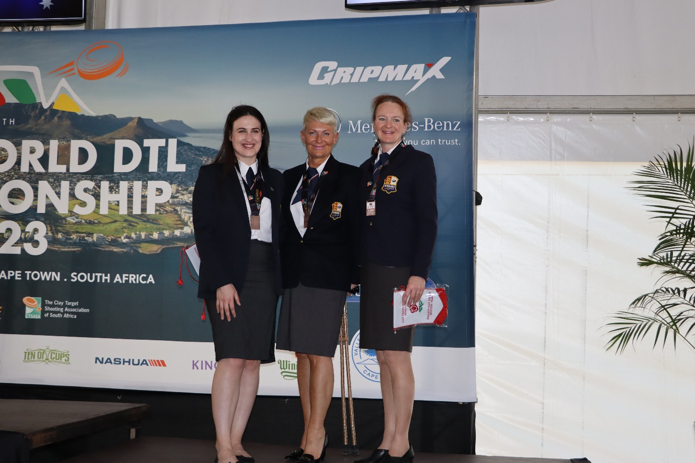
England DTL Ladies Team – DTL World Championships 2023

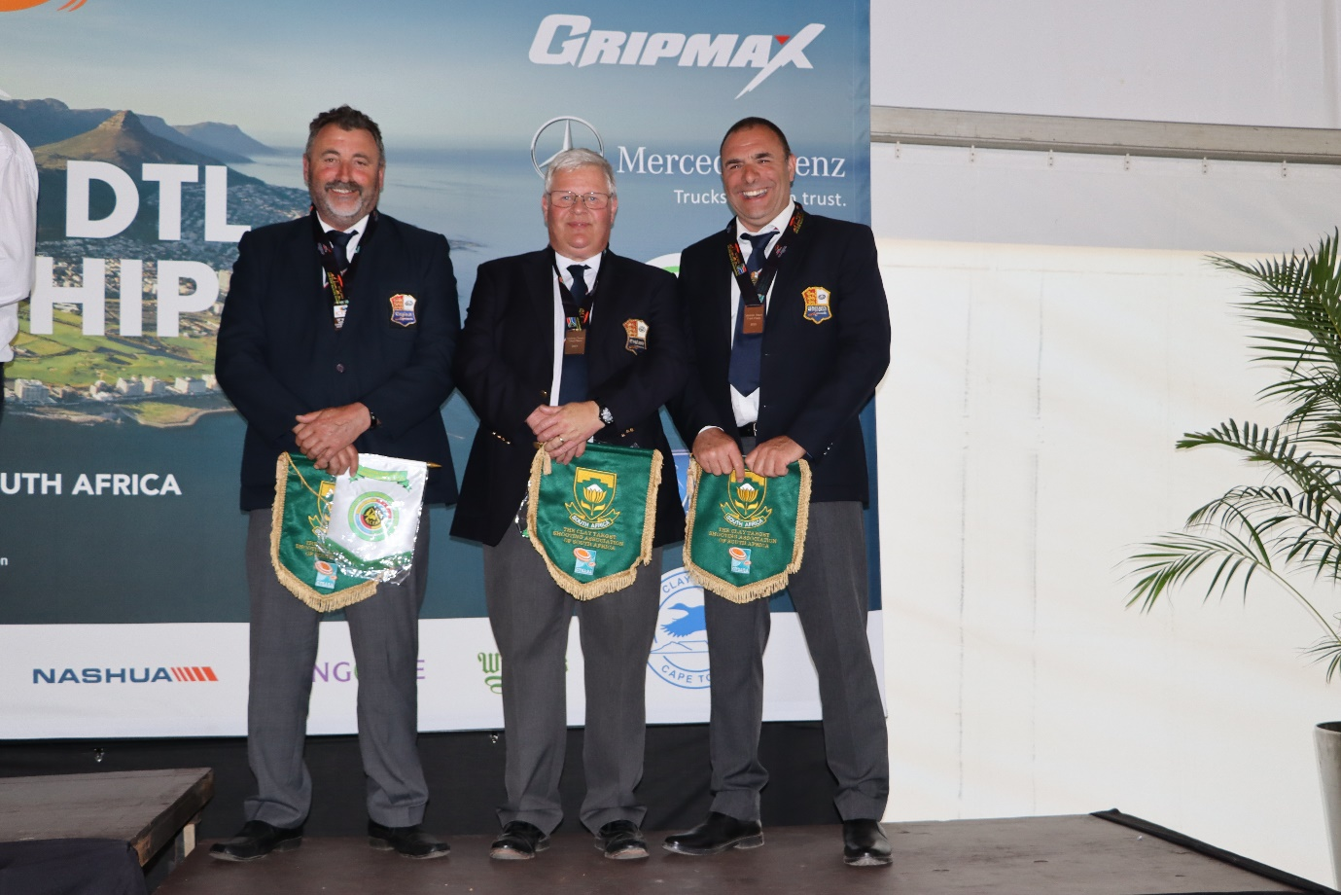
DTL England Veteran Team – DTL World Championship 2023
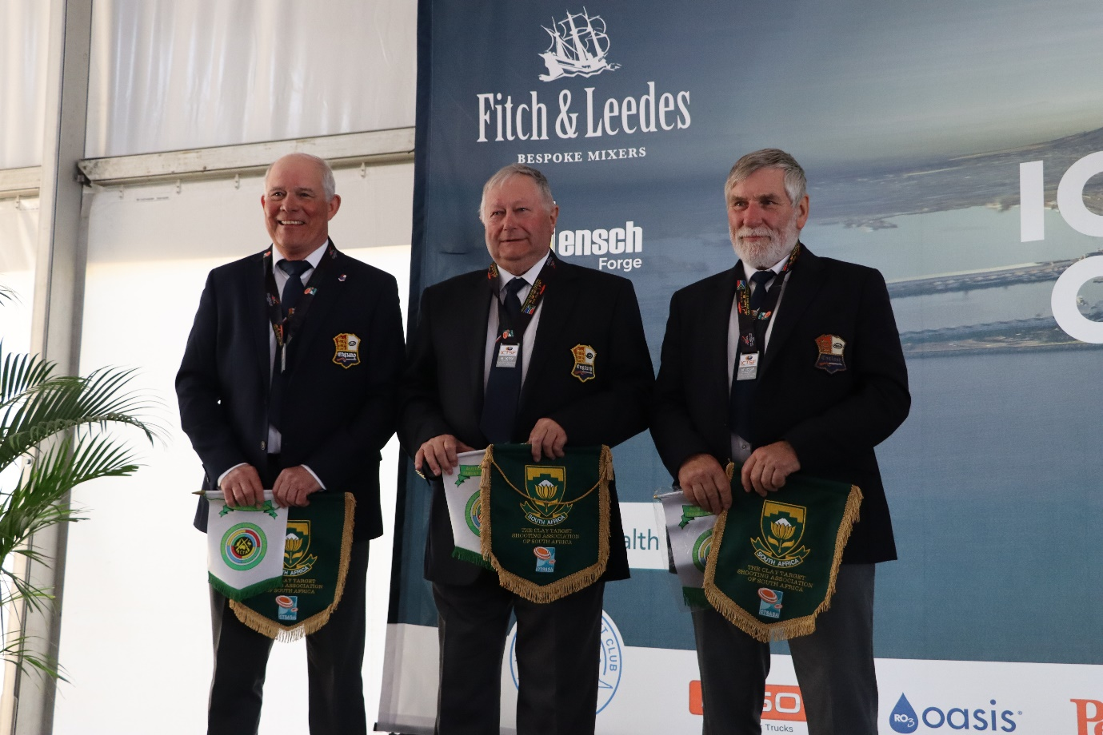
DTL England Super Veterans Team – DTL World Championships 2023

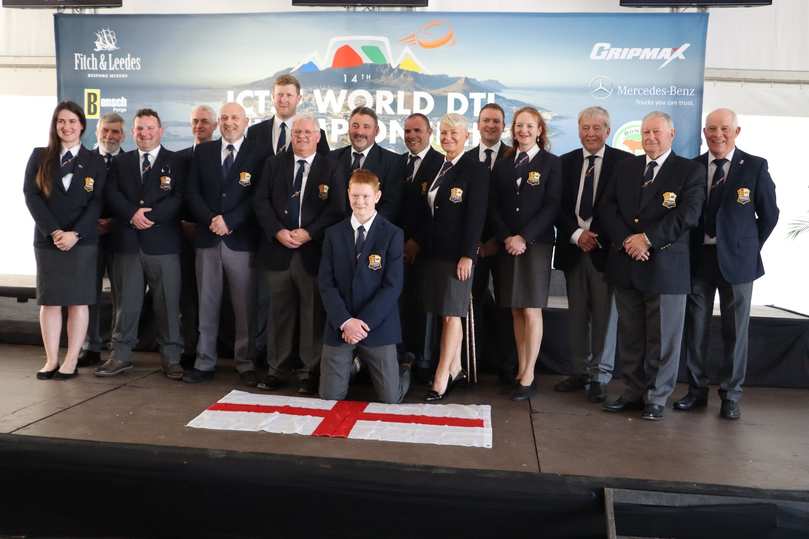
DTL England Team – DTL World Championships 2023
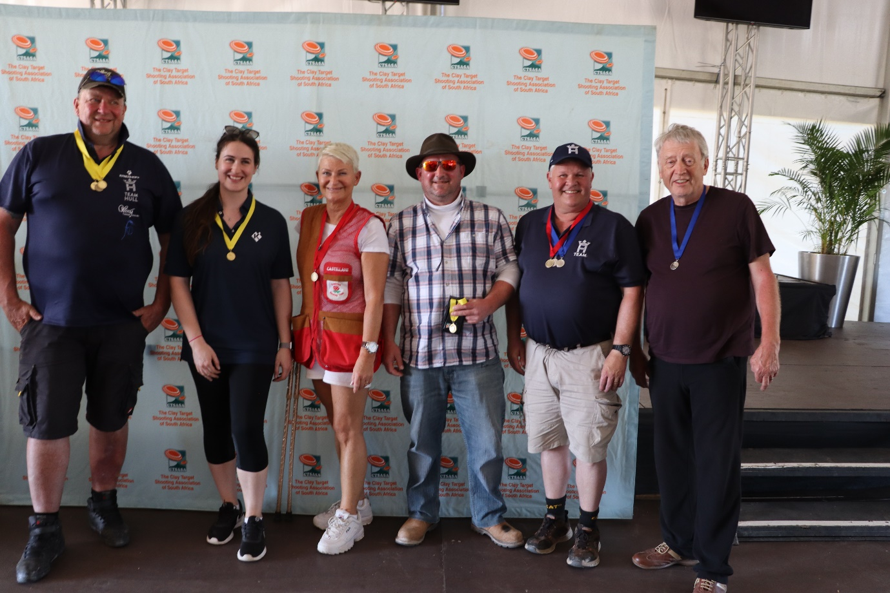
South African Championship Medal Winners

