The Clay Pigeon Shooting Association Ltd
Edmonton House, National Shooting Centre,
Brookwood, Woking,
Surrey, GU24 0NP
Telephone: +44 (0) 1483 485400 Fax: +44 (0) 1483 485410

5th November 2018

Dear Secretary,

The Clay Pigeon Shooting Association wishes to extend a very cordial invitation to your Association to participate officially in the forthcoming:

43rd Olympic Trap Home Countries International Tournament

To be held at: National Clay Shooting Centre
Bisley Camp
Brookwood
Woking
Surrey
GU24 0PB

Tel: 01483 797666
www.nsc-clays.co.uk

On: Friday 23rd and Saturday 24th August 2019.

The Tournament will be held over 200 targets (100 each day) and Teams will consist of the following:

Senior/Open: Teams of 9 shooters (6 scores to count)
Ladies: Teams of 2 shooters
Juniors: Teams of 2 shooters Under 21 on 01/01/2019
Veterans: Teams of 2 shooters 55 or over on 01/01/2019
Super Veterans: Teams of 2 shooters 65 or over on 01/01/2019
Combined Lady/Junior/Veteran/Super Veteran – best 4 scores to count.

The entry fee is £64 per person for the HCIT competition.

Squad selection will take place at 3pm on Thursday 22nd August at NCSC, with Team Managers requested to please be in attendance.

Practice will be available at the ground on Thursday 22nd August (10.30am-5pm), with a registered competition taking place on Sunday 25th August.

The post-Tournament banquet and Team photographs will take place at:
Doubletree by Hilton
Victoria Way,
Woking
GU21 8EW

www.doubletree.hilton.com/woking
Tel: 01482 221000

The photographs’ will take place at 6.30pm, on Saturday 24th August, with the banquet commencing at 7pm. Banquet tickets will cost £42 per person, with final numbers attending, top table names, and any special dietary requirements, all required at least 2 weeks prior to the event.

A special rate at the Doubletree Hilton has been negotiated of £99 Bed & Breakfast per room per night.Please call 01483 221000 and quote “CPSA01” for the discounted rate. For details of alternative hotels close to Woking or NCSC please visit
https://www.hotels.uk.com/uk/surrey/woking/hotels

Please ensure that all Trophies are returned to the ground by 3pm Thursday 23rd August.

Please see the link below for a Shotgun Permit application, for those of you requiring one please note that Visitors Shotgun Permits can take up to 60 days for Surrey Police to complete and return. For full details on the new requirements for VSP’s, please visit https://www.cpsa.co.uk/vsp

The CPSA looks forward to welcoming your teams to the NCSC.

Yours Sincerely,

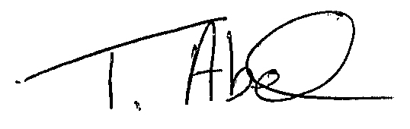
Trudy Abel
England Team Co-ordinator
trudy@cpsa.co.uk
01483 485401.

