The Clay Pigeon Shooting Association Ltd
Edmonton House, National Shooting Centre,
Brookwood, Woking,
Surrey, GU24 0NP
Telephone: +44 (0) 1483 485400 Fax: +44 (0) 1483 485410

12th November 2018

Dear Secretary,

The Clay Pigeon Shooting Association wishes to extend a very cordial invitation to your Association to participate officially in the forthcoming:

Down The Line Home Countries International Tournament

To be held at: Bywell Shooting Ground
Bywell Farm
Felton
Northumberland
NE65 9QQ

01670 787827
www.bywellshootingground.com

On: Thursday 18th July 2019, followed by the British Open on Friday 19th July and the European DTL on Saturday 20th and Sunday 21st July.

The Home International Tournament and British Open will be held over one day of 100 targets. Teams will consist of the following:

Senior/Open: Teams of 20 shooters (16 scores to count)
Ladies: Teams of 5 shooters (4 scores to count)
Juniors: Teams of 5 shooters (4 scores to count) Under 21 on 01/01/2019
Veterans: Teams of 5 shooters (4 scores to count) 60 or over on 01/01/2019
Super Veterans: Teams of 5 shooters (4 scores to count) 65 or over on 01/01/2019

The entry fee is £32 per person for the HCIT competition.
The entry fee is £52 per person for the British Open competition.

The post-Tournament banquet and Team photographs will take place on Thursday 18th July at:
Newcastle United Football Club
St James’ Park
Newcastle Upon Tyne
NE1 4ST

The photographs’ will take place at 6.30pm, with the banquet commencing at 7.30pm. Banquet tickets will cost £42 per person, with final numbers attending, top table names, and any special dietary requirements, all required at least 2 weeks prior to the event.

The European Championships will be held over two days of 100 targets each day (200 in total). Teams will consist of the following:

Senior/Open: Teams of 5 shooters (all scores to count)
Ladies: Teams of 3 shooters (all scores to count)
Juniors: Teams of 3 shooters (all scores to count) Under 21 on 01/01/2019
Veterans: Teams of 3 shooters (all scores to count) 55 or over on 01/01/2019
Super Veterans: Teams of 3 shooters (all scores to count) 65 or over on 01/01/2019

The entry fee is £104 per person for the European Championships with Team fees of £40 for the Open team and £35 for the L/J/V/SV Teams.

Please ensure that all Teams are submitted on the enclosed ICTSC Team submission form.

Trophies are required to be returned to the ground by 3pm on Wednesday 17th July.

Practice is available from Wednesday 17th July 12-5pm.

For local hotels please see Bywell’s website, or http://www.hotels.uk.com/attractions-uk/Newcastle+United+Football+Club.htm for hotels local to the banquet.

Please see the link below for a Shotgun Permit application, for those of you requiring one please note that Visitors Shotgun Permits can take up to 60 days for Surrey Police to complete and return. For more details on the new requirements for VSP’s please visit https://www.cpsa.co.uk/vsp

The CPSA looks forward to welcoming your teams to Bywell.

Yours Sincerely,

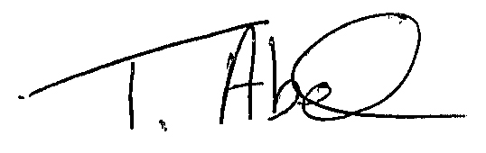
Trudy Abel
England Team Co-ordinator
trudy@cpsa.co.uk
01483 485401.

